**WORK INSTRUCTIONS FOR** **CAST HOUSE MUDGUN MACHINE OPERATION (BF1 & BF2)**

**Responsibility: Furnace Incharge/ Tap hole Operator**

**Mudgun Operation**

**Identified Hazards:**

1. Contact with hot metal& slag
2. Fall of Person
3. Impact with mud gun
4. Hose pipe bursting, puncture & fire
5. Contact with hot mud gun clay
6. Trapping of hand or figures
7. Nonuse of PPE &WI
8. Improper house keeping
9. Inadequate local lighting
10. Touching of mudgun clay in hot barrel
11. Stoppage of mudgun operation during closing of cast due to failure of hydraulic hoses
12. Gas formation in mudgun barrel due to jam nozzle and not retracting piston back.
13. Slip due to oil leakage

**Significant Aspect**

Noise Generation

**Responsibility: Furnace Incharge /foreman/Sr. Tap hole operator**

1. Unauthorized operation or repair of any equipment is a punishable offence.
2. Ensure that the mud gun hooter (for swiveling) is audible loud and clear in cast house.
3. Ensure mudgun operating panel switch buttons are in place and in healthy condition. Broken/missing push button shouldn’t be operated.
4. Ensure mud gun nozzle is thoroughly cleaned, person carrying out the activity should wear all PPE’s viz safety shoes, safety hand gloves, etc.
5. While filling the mudgun barrel with the anhydrous clay ensure that no other person is operating the mudgun injection piston i.e. (single person operation).
6. Ensure while filling the clay, one shouldn’t insert his hand to push the clay cake inside the barrel.
7. Ensure clay cake is placed in front of the piston through the barrel opening and mudgun piston is used for pushing and packing the clay in the barrel.
8. Ensure no person is standing or moving in front of the mudgun nozzle while taking the piston forward and backward to avoid burn injury due to contact of hot clay.
9. Ensure swing area of mud gun is barricaded with link chain before the translation (to or fro) of mudgun.
10. Ensure mudgun trial is taken to check the tap hole center before opening of the cast,
11. Ensure that the taphole face and main runner jam is cleared of all slag and metal jam before closing the cast to avoid clay spillage.
12. Reduce wind volume to minimum incase mudgun get stuck in the runner during closing of cast so as to minimize the damage due to burning.
13. Ensure that the nozzle is not jammed before closing the cast, by pushing small amount of clay.
14. Ensure that mudgun is not operated while cleaning the protruded clay from mudgun nozzle before closing the cast.
15. Check the hydraulic hosses for leakage due to wearing/burning.
16. Check for power supply indication on the control station.
17. Select Clay gun operation by turning key towards ‘CLAY GUN’.
18. Check for siren operation by pressing ‘Alarm Start’ button & for stopping press ‘Alarm Stop’.
19. Check Butterfly valve glow indication which indicates that the suction valve of the pump is open.
20. Release the mud gun push button
21. Press ‘Start’ button for switching on the hydraulic system. After staring, indication for Pump 1, 2 or 3 whichever is in remote mode will glow and also ‘Start’ indication above start push button will glow.
22. For taking Mud gun towards taphole press ‘Swiveling Forward’ push button. Release the push button when the Mud gun reaches taphole.
23. Operate the latch push button for clamping the latch to forward. Press the latch push button for engaging latch.
24. Then inject the mud gun clay by pressing injection forward button.
25. After completing the injection,
26. Stop the hydraulic system by pressing ‘Stop’ push button.
27. Turn the selector switch the on to ‘None’ position.
28. Push the emergency position.
29. Remove the key from the ‘Equipment Selector switch’
30. Keep the mud gun Infront of the tap hole for at least 10 minutes after closing the cast. Increasing this time shall be based on the quality of the clay.
31. After 10 minutes for removing the mud gun:
    1. Press the Reverse injection push button for taking the joystick backward till the piston is fully retracted.
    2. Operate the unlatch push button for disengaging the mud gun. Take the mud gun back by operating the push button of mud gun reverse swiveling backward once latch crosses the latch hook for disengaging position. Once latch is disengaged, mud gun taken back, bring the latch in normal position by operating the latch push button.
    3. Take the mud gun to the safe position slowly.
    4. Immediately after the mudgun is taken back, open the barrel inspection door to release all gases.
    5. Ensure mudgun nozzle is thoroughly cleaned
32. Ensure that mudgun piston is fully retracted back, inspection door on the barrel is kept open and mudgun nozzle is cleaned, before giving clearance to mechanical for any cutting/welding job on the mudgun barrel.
33. Ensure that the spare mudgun nozzle and nozzle cap is available in the cast house.
34. Keep the Mudgun area clean.
35. No person is allowed to do taphole cleaning during mudgun operation.
36. Ensure chipped and damaged nozzle which is causing clay spillage shall be replaced immediately.
37. Idle running of the equipment should be avoided.

**5. Filling of Mudgun barrel.**

1. **Mud gun filling and operation shall be done by single person.**
2. Ensure no person is standing or moving in front of the mudgun nozzle while taking the piston forward and backward to avoid burn injury due to contact of hot clay.
3. Insert mudgun clay from the opening of the mudgun barrel and switch ON the injection forward local button provided near mud gun for pushing and tightening of   the clay into the barrel.
4. Don’t use or insert hand to push the clay in the barrel.
5. When mudgun is filled put off the pumps/remote.
6. Clean the taphole area of metal and slag jam.
7. Idle running of the mud gun should be avoided.
8. While filling the mudgun, the mudgun panel room has to be locked and the key to be kept with the operator while the mudgun is being filled. After the mudgun filling activity is over the mudgun panel room to be kept open. The mudgun operator should ensure to hand over the key to his reliever or hand over the key to the control room staff without fail after completion of his shift.

Main emergency stop push button installed in series to lockable emergency key switch on BF1 Mudgun/Drill machine operating desk.

So, whenever any workmen of production or mechanical fitter wants to work on Mudgun/Drill machine then he has to follow below steps.

1. Keep mudgun/drill machine selector switch in off position and remove the key.

2. Put lockable emergency key switch in off position and remove the key (this switch key will come out only in off position). Ensure healthiness of key switch at least once in shift.

3. Press main emergency stop push button.

4. After doing all above 1,2 & 3 steps operator should cross check and conform that any Mudgun or Drill machine operation are not taking place

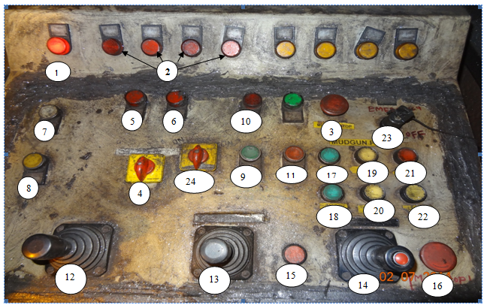

**BF1 Mud gun Panel**

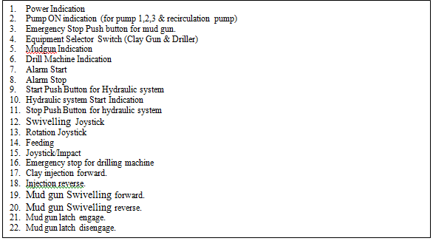

23. Lockable Key.

24. Pump Selector.

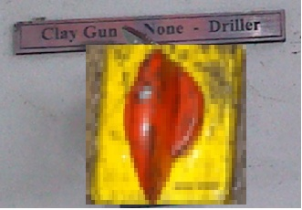

Equipment Selector Switch

For selecting Clay Gun or Drill Machine

|  |  |
| --- | --- |
| Technical parameters | |
|  | |
| Operating pressure | 13MPa |
| Operating flow | rotator:70 L/min |
|  | impact:90 L/min |
| Swivelling mechanism | |
| Operating pressure | 13 MPa |
| Operating flow | 35~75 L/min |

BF2 Drill machine/mudgun operation panel

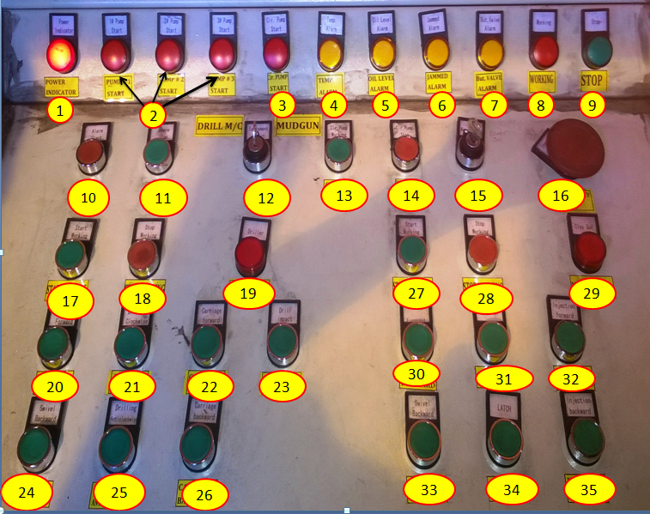

|  |  |  |  |  |  |
| --- | --- | --- | --- | --- | --- |
| **1** | Power Indicator | **13** | Circulation pump start | **25** | Drilling Anticlockwise |
| **2** | Pump On indications | **14** | Circulation pump stop | **26** | Carriage backward |
| **3** | Circulation Pump | **15** | Panel On/Off key | **27** | Mudgun start |
| **4** | Temperature Alarm | **16** | Emergency stop | **28** | Mudgun stop |
| **5** | Oil Level Alarm | **17** | Start drill machine | **29** | Mudgun on indication |
| **6** | Jammed Alarm | **18** | Stop Drill Machine | **30** | Mudgun swivel forward |
| **7** | Butterfly Valve Alarm | **19** | Drill Machine on | **31** | Unlatch |
| **8** | Working Indication | **20** | Drill M/C Swivel forward | **32** | Injection forward |
| **9** | Stop Indication | **21** | Drilling Clock wise | **33** | Swivel Backward |
| **10** | Alarm Start | **22** | Carriage forward | **34** | Latch |
| **11** | Alarm Stop | **23** | Impact drilling | **35** | Injection backward |
| **12** | Drill/ Mudgun selector | **24** | Drill M/C swivel backward |  |  |

|  |  |  |
| --- | --- | --- |
| **Prepared By:**  Head – Production PIDI | **Reviewed & Issued By:**  Management Representative | **Approved By:**  Head – Pig Iron Division |
| **Signature:** | **Signature:** | **Signature:** |
| **Date: 15.07.2022** | **Date: 15.07.2022** | **Date: 15.07.2022** |

|  |  |  |  |
| --- | --- | --- | --- |
| **Amendment Record** | | | |
| **Revision date** | **Manual Section ref. and para** | **Brief details of revision** | **New Revision No.** |
| 15.07.2022 | Work instructions for cast house Mudgun Machine operation (BF1 & BF2) | Change in format | 14 |
|  |  |  |  |